Real-World Data Project — Retail Sales
End-to-end analysis & forecasting across 4 product categories, 2024–2025

1. Objective
This project applies the full data-science workflow — cleaning, exploratory analysis, and predictive forecasting — to a two-year daily retail sales dataset spanning four product categories (Electronics, Clothing, Grocery, Home & Garden). It mirrors a real retail analytics use case: understand what's driving sales, then forecast near-term demand.
The dataset simulates a realistic point-of-sale export: an underlying growth trend, weekly and seasonal patterns, holiday spikes (Black Friday, December), plus the messiness real exports contain — missing days, duplicate transaction logs, and data-entry outliers.

2. Data Cleaning
Step | Result
Raw rows | 2,939 (daily × 4 categories, 2 years)
Duplicate rows removed | 14
Missing values | 58 → 0 (interpolated within each category's time series)
Outliers capped (per-category IQR) | 81 rows
Cleaned rows | 2,925
Missing values were filled using time-series interpolation within each category (rather than a flat average), since sales on a missing day are best estimated from neighboring days. Outliers were capped per-category using a generous IQR bound — wide enough to preserve legitimate holiday spikes while catching clear data-entry errors (e.g. an accidental extra digit).

3. Exploratory Analysis

3.1 Sales Trend by Category
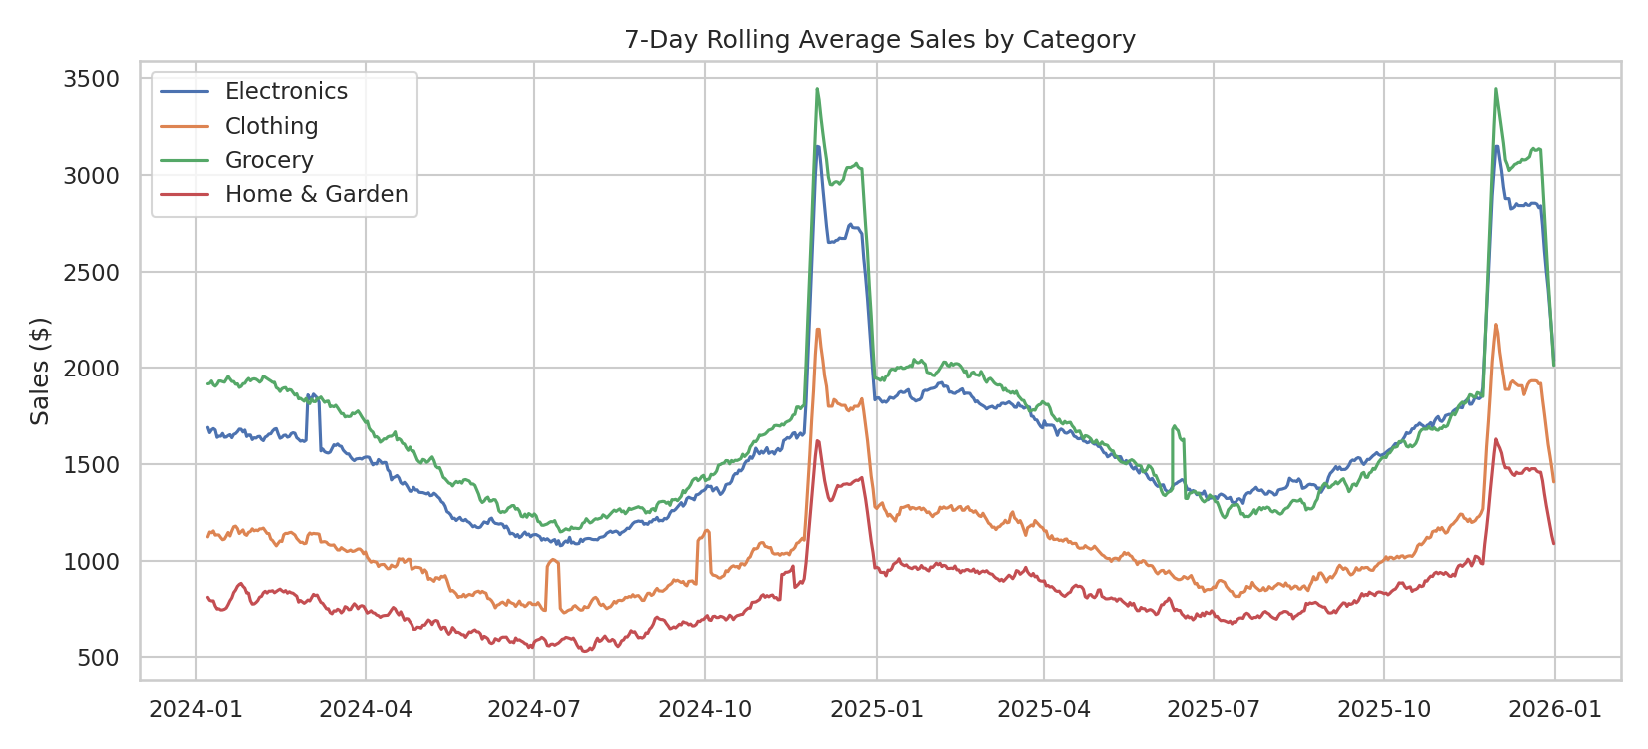
Figure 1 — 7-day rolling average sales by category
All categories show a mild upward trend plus a sharp shared spike around Black Friday (late November) and a smaller lift through December. Grocery shows the least seasonal swing (a staple category), while Electronics and Clothing show the largest holiday-driven jumps.

3.2 Category Performance
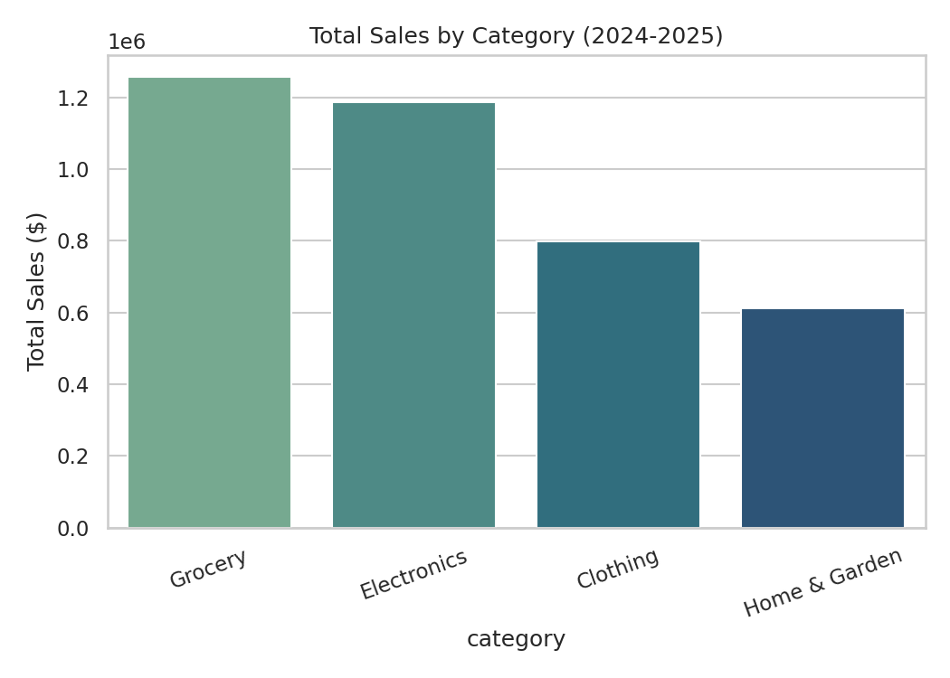
Figure 2 — Total sales by category over the full period
Grocery was the top-selling category overall (~$1.26M), reflecting steady, high-frequency purchases, ahead of Electronics, Clothing, and Home & Garden.

3.3 Day-of-Week Pattern
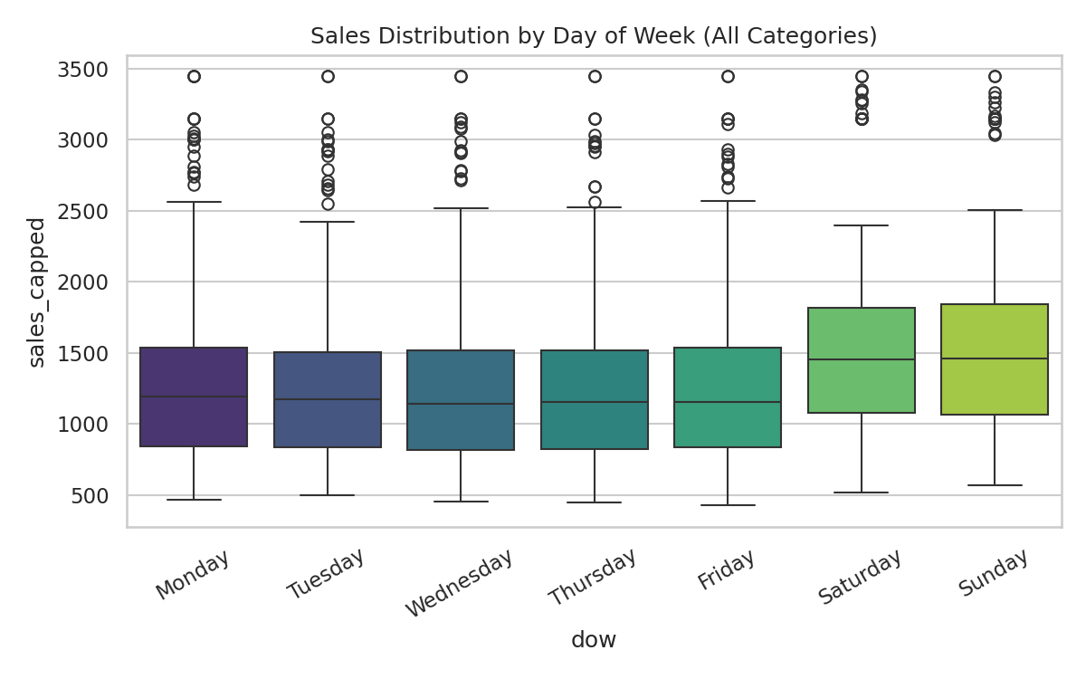
Figure 3 — Sales distribution by day of week
Weekend sales (Saturday/Sunday) are consistently higher across all categories, with Clothing showing the strongest weekend lift — consistent with in-store/leisure shopping behavior.

3.4 Monthly Heatmap
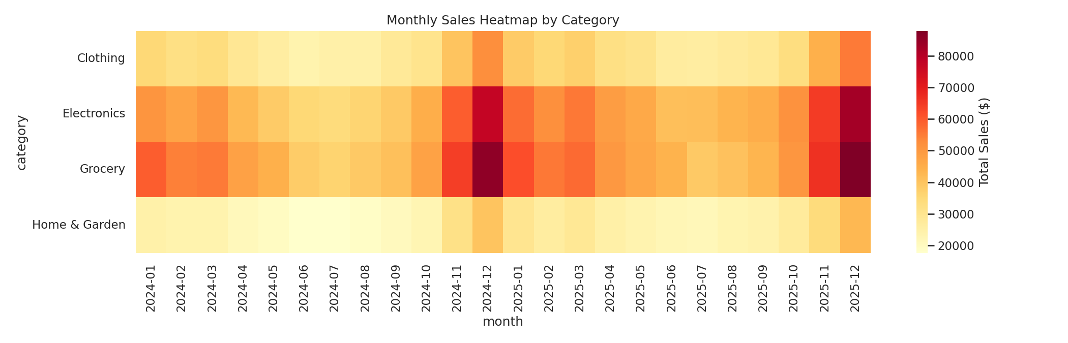
Figure 4 — Monthly total sales by category, both years
The heatmap makes the November spike unmistakable across every category, and shows a mild summer dip — useful for staffing and inventory planning.

4. Forecasting Model
Total daily sales (all categories combined) were forecast using time-based features — day index (trend), day-of-week, month, weekend flag, and holiday-season flag — with the last ~4 months held out as a true out-of-time test set (no shuffling, since this is a forecast, not a random split).
Model | MAE | RMSE | R²
Linear Regression | $861 | $1,100 | 0.692
Random Forest | $594 | $729 | 0.865

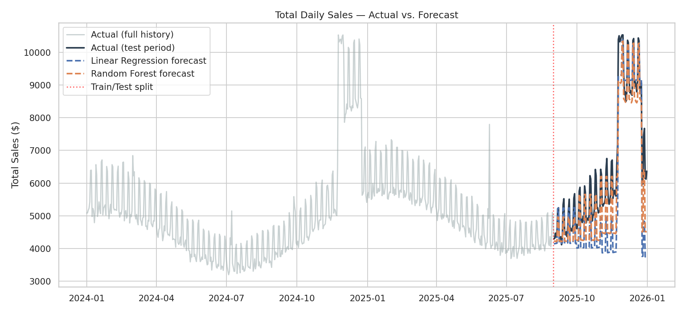
Figure 5 — Actual vs. forecast total daily sales on the held-out test period
The Random Forest model substantially outperforms plain Linear Regression (R² of 0.865 vs. 0.692), because it captures the non-linear weekly/holiday interactions that a straight line cannot. Both models correctly anticipate the holiday spike's timing, though Random Forest tracks its magnitude more closely.

5. Key Takeaways
- Grocery is the top revenue category; Electronics and Clothing are the most holiday-sensitive.
- Weekends reliably outperform weekdays across every category — a clear staffing/inventory signal.
- The Black Friday / December holiday window drives the single largest and most predictable sales spike of the year.
- A Random Forest forecasting model (R² = 0.865, MAE ≈ $594/day) is recommended over a simple linear trend line for demand planning, since it captures seasonal non-linearities a straight line misses.

6. Conclusion
This end-to-end analysis shows how the techniques from the earlier projects — cleaning messy raw data, exploring it for patterns, and building a predictive model — combine into a practical retail decision-support workflow. The resulting forecast could directly inform inventory ordering and staffing decisions ahead of the holiday season.
Deliverables accompanying this report: the full Python pipeline (retail_project.py), the raw and cleaned datasets (retail_sales_raw.csv / retail_sales_cleaned.csv), and an interactive HTML dashboard.

